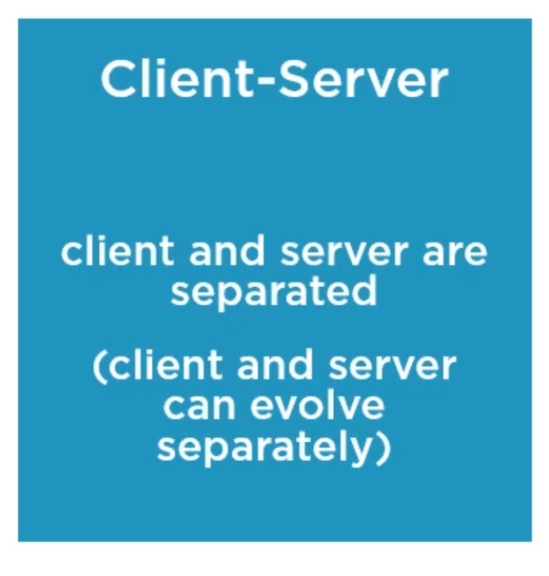

Let's continue with the client-server constraint. This is a very basic fundamental constraint.

It enforces client-server architecture, which in turn enforces separation of concerns. So, the client and the server are completely separated.

A client, or a consumer of the API in our lingo, should not be concerned with how data is stored or how the representation is generated, that's completely transparent.

Our client is Postman in this case. We have nothing to do with programming that at all, and it doesn't know how the API was developed.

So a server, the API in our lingo, should not be concerned with, for example, the user interface, or the user state, or anything related to how the client is implemented.

In other words, we can design our API without knowing anything about Postman. This allows the client and the server to evolve separately.